LEGALEASE AI
AI-Assisted Legal Document Generation System
_____________________________________________
PHASE 7 – PROJECT DOCUMENTATION
Technical Report • Implementation • Testing • Evidence

Submitted By
Team Members
- SATHVIKA V S
- SUMATHI
- RITHIKA P
- SINDHUJA

Department of Computer Science
Shrimati Indira Gandhi College
Affiliated with Bharathidasan University

Academic Year: 2026

Document Guide
This document is structured as a complete technical report for LegalEaseAI. It combines system explanation with implementation evidence from the supplied Visual Studio Code screenshots. Screenshots of the running frontend could not be supplied in this session, so dedicated placeholders are retained for those evidence points.

Section | Topic
1 | Introduction
2 | Project Overview
3 | Problem Statement
4 | Objectives
5 | Proposed Solution
6 | System Features
7 | Technology Stack
8 | System Architecture
9 | System Workflow
10 | Module Description
11 | Project Structure
12 | Implementation Details
13 | Testing Summary
14 | Screenshots / Evidence
15 | Installation and Execution
16 | Project Outcomes
17 | Future Enhancements
18 | Conclusion

1. Introduction
LegalEaseAI is an AI-assisted legal document generation application designed to combine a web-based user interface, a FastAPI backend, request validation, an AI generation layer, and document-formatting utilities. The supplied project implementation shows a modular Python application in which the frontend communicates with backend routes and the backend delegates AI-oriented document generation to a dedicated Gemini service.
The project follows a separation-of-concerns approach. Startup logic is kept in run.py, backend initialization is defined in LegalEaseAPI/main.py, request handling is organized in LegalEaseAPI/routes.py, AI generation is isolated in ai_core/gemini_generator.py, document formatting is handled in utils/formatter.py, and the user-facing application is implemented in frontend/app.py. A dedicated stylesheet in frontend/static/style.css provides the visual theme.
The documentation therefore presents LegalEaseAI not simply as a collection of source files, but as an integrated software system. Each major implementation decision is connected to its role in the overall workflow and, where available, supported by a project screenshot.
Evidence principle
The screenshots included in this report are treated as implementation evidence. Claims are limited to what is visible in the supplied project structure, source-code views, and successful startup terminal output.

2. Project Overview
LegalEaseAI is organized as a local web application with two principal runtime-facing components: a FastAPI backend and a Streamlit frontend. The startup script launches the backend through Uvicorn and starts the frontend service. The terminal evidence supplied for the project shows the backend at port 8000 and the frontend at port 8501.
The AI layer is represented by GeminiDocumentGenerator. The supplied source view shows that this class loads environment variables, obtains the GEMINI_API_KEY configuration value, and configures a Gemini model. The backend routes create an instance of this generator and expose request-oriented functionality through an API router.
The formatting layer provides text sanitization and output-cleaning functions and imports both python-docx and ReportLab components, indicating that the application contains utilities for structured document output. The exact final UI output is reserved for the frontend evidence section because those browser screenshots were not available in the current session.

2.1 High-Level Project Components
Startup layer — run.py coordinates application startup and defines the backend/frontend ports.
Backend layer — FastAPI provides the application object, middleware configuration, and route registration.
API layer — routes.py defines API routing, request models, validation, and Gemini service initialization.
AI layer — gemini_generator.py encapsulates Gemini configuration and AI-assisted document generation logic.
Formatting layer — formatter.py sanitizes and prepares generated text for document-oriented output.
Frontend layer — frontend/app.py initializes the Streamlit application and its page configuration.
Styling layer — style.css defines the Luna Blue + Green visual system used by the frontend.

3. Problem Statement
Preparing legal-style documents manually can require repeated drafting, formatting, editing, and organization. A user may need to provide document-specific information, transform that information into a structured draft, and then prepare the resulting content for a usable document format. Repeating these steps manually can make the process time-consuming and inconsistent.
The project addresses this software-process problem by creating a centralized application flow in which user-facing input can be sent to a backend API, validated using structured request models, processed through an AI generation component, and passed through output-formatting utilities.
From a software-engineering perspective, the problem is also one of maintainability: mixing UI code, API logic, AI integration, and formatting code in a single file makes a project harder to test and extend. LegalEaseAI separates these responsibilities into modules so that each major concern has a defined location.
4. Objectives
The main objective is to develop a modular AI-assisted application for generating structured legal document drafts through a web interface. The implementation evidence supports the following project objectives:
Provide a user-facing Streamlit interface for interacting with the application.
Provide a FastAPI backend for structured API-based communication.
Validate incoming document-generation requests using Pydantic models and field constraints.
Integrate a Gemini-based generation component through a dedicated service class.
Load sensitive configuration such as the Gemini API key from environment variables rather than hard-coding it in source code.
Clean and sanitize generated text before document-oriented formatting.
Separate application startup, backend routing, AI generation, formatting, frontend presentation, and styling into independent modules.
Provide a repeatable local execution process through run.py.
Maintain a consistent visual identity using the project's Luna Blue + Green stylesheet.

5. Proposed Solution
The proposed solution is a layered web application. At the presentation layer, Streamlit provides the user interface. The backend layer is implemented using FastAPI and exposes API routes. The request layer uses Pydantic models to define and validate incoming data. The AI layer uses GeminiDocumentGenerator to communicate with the configured Gemini model. Finally, the formatting layer prepares generated text for document output.
5.1 Solution Characteristics
Modular — each major responsibility is implemented in a dedicated package or module.
Configurable — environment variables are loaded through python-dotenv.
API-driven — the frontend can communicate with the backend through HTTP requests.
Validation-aware — request fields include explicit constraints in the visible routes.py implementation.
AI-enabled — the project includes a dedicated Gemini document-generation class.
Output-oriented — formatting utilities prepare generated content for document use.
Maintainable — the project structure makes individual layers easier to locate and modify.
5.2 Scope of the Current Evidence
The supplied screenshots establish the architecture, startup behavior, and major implementation modules. They do not include the final browser interface or a generated-document result. Those screenshots should be added later in Section 14 and the corresponding feature descriptions can then be expanded with exact UI evidence.

6. System Features
6.1 Web-Based User Interface
The frontend is implemented with Streamlit. The visible app.py source configures a centered page layout and loads the project environment. The browser-based interface is intended to provide the interaction point for document-generation requests.
6.2 API Backend
FastAPI is used as the backend framework. main.py creates the FastAPI application, configures CORS middleware, and includes the API router.
6.3 Request Validation
routes.py imports Pydantic BaseModel, Field, and field_validator. The visible DocumentRequest model applies a minimum and maximum length constraint to document_type, providing a structured validation layer.
6.4 Gemini AI Integration
gemini_generator.py defines GeminiDocumentGenerator and loads the Gemini API key from the environment. The source describes the component as the LegalEase AI Core and identifies the Gemini model as the generation engine.
6.5 Error Handling
The visible routes.py initialization wraps Gemini generator creation in a try/except block and records GEMINI_READY and GEMINI_ERROR state. This provides an explicit way to represent AI-service initialization success or failure.
6.6 Text Sanitization and Formatting
formatter.py provides sanitize_text and format_document_output functions. The visible code strips surrounding whitespace and removes unwanted Markdown code-fence patterns before continuing with document formatting.
6.7 Document-Oriented Output Support
formatter.py imports python-docx's Document and ReportLab A4/canvas components, providing the implementation foundation for structured document output.
6.8 Consistent Visual Theme
style.css defines a Luna Blue + Green palette with navy, blue, teal, and green variables and success-state styling.

7. Technology Stack
Technology / Component | Role | Evidence in Project
Python | Primary programming language | All visible implementation files use Python.
FastAPI | Backend web/API framework | main.py imports FastAPI and creates app = FastAPI(...).
Uvicorn | ASGI server for backend | run.py builds a Uvicorn command for LegalEaseAPI.main:app.
Streamlit | Frontend web application framework | frontend/app.py imports streamlit as st and calls st.set_page_config.
Pydantic | Request data modeling and validation | routes.py imports BaseModel, Field, and field_validator.
Google Gemini / google-genai | AI generation service | gemini_generator.py imports google.genai and defines GeminiDocumentGenerator.
python-dotenv | Environment configuration | gemini_generator.py and frontend/app.py load .env values.
python-docx | DOCX-oriented document handling | formatter.py imports Document.
ReportLab | PDF-oriented output support | formatter.py imports A4 and canvas.
CSS | Frontend styling | frontend/static/style.css defines the Luna Blue + Green theme.

8. System Architecture
The visible implementation supports a layered architecture in which startup orchestration, presentation, API routing, AI generation, and formatting are separated. The architecture reduces coupling by allowing the frontend, API, AI service, and formatting utility to be developed as distinct concerns.
8.1 Logical Architecture
Presentation Layer
Streamlit frontend in frontend/app.py. Responsible for page configuration and user-facing interaction.
Application/API Layer
FastAPI application in LegalEaseAPI/main.py. Responsible for creating the backend application, middleware, and router registration.
Request Layer
LegalEaseAPI/routes.py. Defines API routing and Pydantic request structures.
AI Service Layer
ai_core/gemini_generator.py. Loads configuration and initializes the Gemini document-generation service.
Formatting Layer
utils/formatter.py. Sanitizes generated text and prepares it for document-oriented output.
Execution Layer
run.py. Starts the backend and frontend services and defines the local ports.
Architecture flow
User Interface → API Request → Validation → Gemini Document Generator → Text Formatting → Document-Oriented Output → User Access

10. Module Description
10.1 run.py
Acts as the application launcher. It imports subprocess, sys, and time; defines BACKEND_HOST, BACKEND_PORT, and FRONTEND_PORT; constructs the Uvicorn backend command; and coordinates the service startup.
10.2 LegalEaseAPI/main.py
Creates the FastAPI application, assigns the title 'LegalEase API', provides a backend description and version, configures CORS middleware, and includes the API router.
10.3 LegalEaseAPI/routes.py
Creates an APIRouter, imports the Gemini document generator, initializes the Gemini service with explicit readiness/error state, and defines Pydantic request structures.
10.4 ai_core/gemini_generator.py
Provides the GeminiDocumentGenerator class. It loads environment variables, retrieves GEMINI_API_KEY, validates that the key exists, and configures the Gemini model.
10.5 utils/formatter.py
Provides text sanitization and output-formatting functions. It removes surrounding whitespace and cleans accidental Markdown code fences. It imports DOCX and ReportLab components for document output.
10.6 frontend/app.py
Initializes the Streamlit application, resolves the project root, loads the .env file, and configures the Streamlit page title, icon, layout, and sidebar state.

10.7 frontend/static/style.css
Defines the project's Luna Blue + Green design system through CSS variables and styles the Streamlit page background and other interface elements.

11. Project Structure
The project is organized into dedicated directories for AI logic, frontend presentation, backend API logic, utilities, and the Python virtual environment. The structure visible in Visual Studio Code provides a clear map of the major source components.
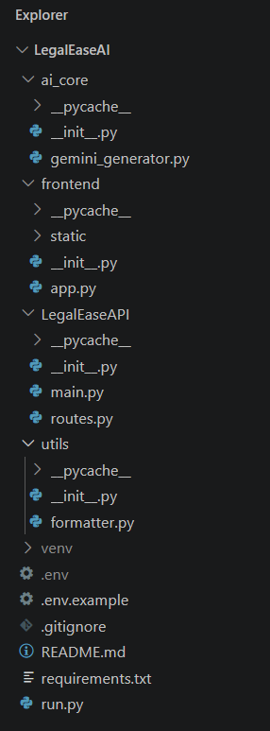
Fig. 11.1 – Complete LegalEaseAI project structure in Visual Studio Code
The ai_core directory contains the Gemini generation component. The frontend directory contains app.py and static resources. LegalEaseAPI contains the backend application and routes. The utils directory contains formatter.py. The project root contains environment/configuration files, README.md, requirements.txt, and run.py. The venv directory represents the project's local Python virtual environment.

11.1 Structure Summary
- ai_core/ — AI and Gemini-related functionality.
- frontend/ — Streamlit frontend and static styling resources.
- LegalEaseAPI/ — FastAPI application and route definitions.
- utils/ — reusable document/text formatting utilities.
- venv/ — local Python virtual environment.
- .env / .env.example — environment configuration files.
- requirements.txt — project dependency declaration.
- README.md — project documentation entry point.
- run.py — application startup script.
12. Implementation Details
This section documents the implementation evidence file by file. Each screenshot is positioned immediately after the explanation of the responsibility it demonstrates, making the report easier to audit and understand.
12.1 Application Startup and Service Initialization
run.py establishes the local runtime configuration. It defines the backend host as 127.0.0.1, the backend port as 8000, and the frontend port as 8501. The backend command invokes the current Python executable with the Uvicorn module and points Uvicorn to LegalEaseAPI.main:app. The script therefore provides a single entry point for starting the application services.
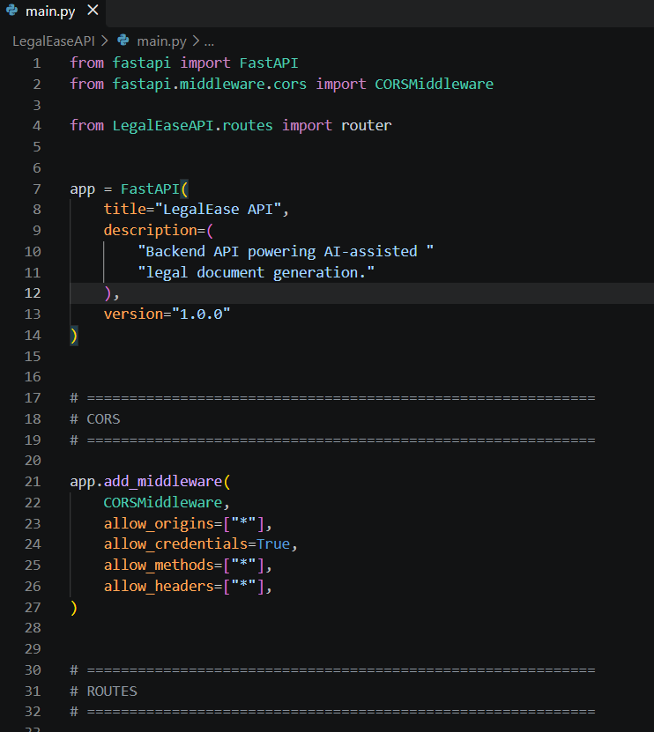
Fig. 12.2 – FastAPI backend initialization, CORS configuration and route registration

12.3 API Routing and Request Validation
routes.py is responsible for the API-facing request layer. The visible source imports APIRouter, HTTPException, status, and Pydantic validation tools. It initializes GeminiDocumentGenerator and stores explicit readiness and error states. The DocumentRequest model uses a document_type field with visible minimum and maximum length constraints, providing structured input validation before deeper processing.

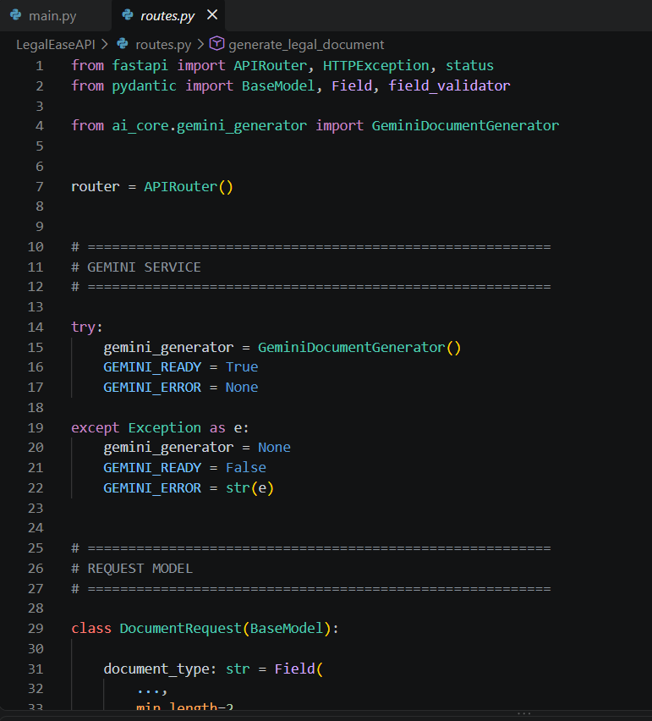
Fig. 12.3 – API routing, Gemini service initialization and request validation

12.4 AI-Based Legal Document Generation
gemini_generator.py contains the core AI service class, GeminiDocumentGenerator. It loads environment variables using load_dotenv, retrieves GEMINI_API_KEY from the environment, and raises a clear ValueError if the required key is missing. The source also configures the Gemini model through an environment-based model name, keeping service configuration outside the main application logic.
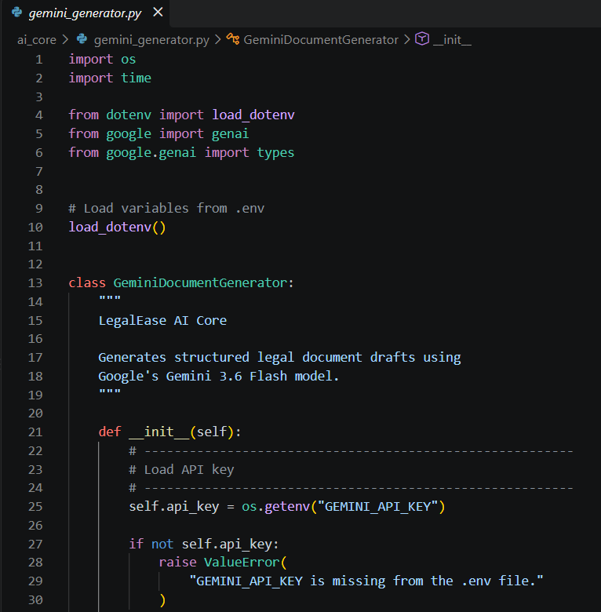
Fig. 12.4 – Gemini AI integration and environment-based model configuration

12.5 Document Formatting and Output Processing
formatter.py is the document-preparation utility. The visible code imports python-docx and ReportLab components and defines sanitize_text and format_document_output. Sanitization handles empty input safely and strips surrounding whitespace. The formatting function also removes accidental Markdown code fences, helping convert model output into cleaner document-ready text.

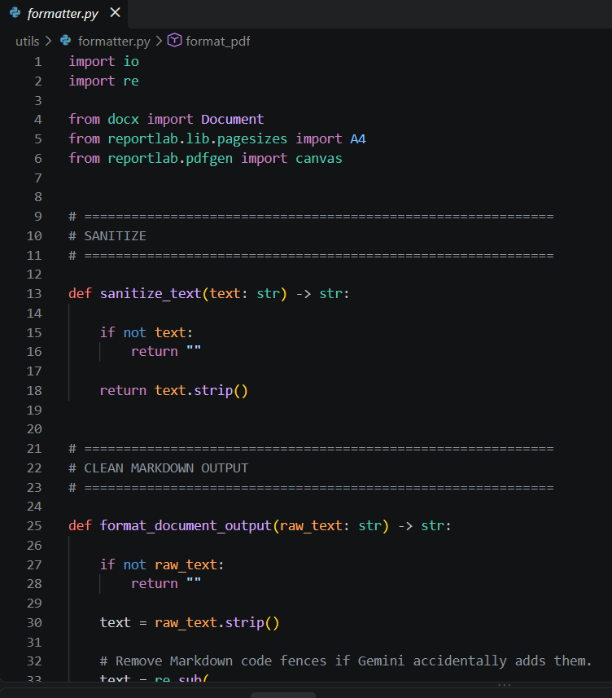
Fig. 12.5 – Text sanitization and document output formatting

12.6 Frontend Application and User Interface
The frontend app.py source initializes the Streamlit application, imports requests and dotenv support, determines the project root, loads the .env file, and configures the Streamlit page. The page is set to a centered layout and starts with the sidebar collapsed. This file is the main presentation-layer entry point.
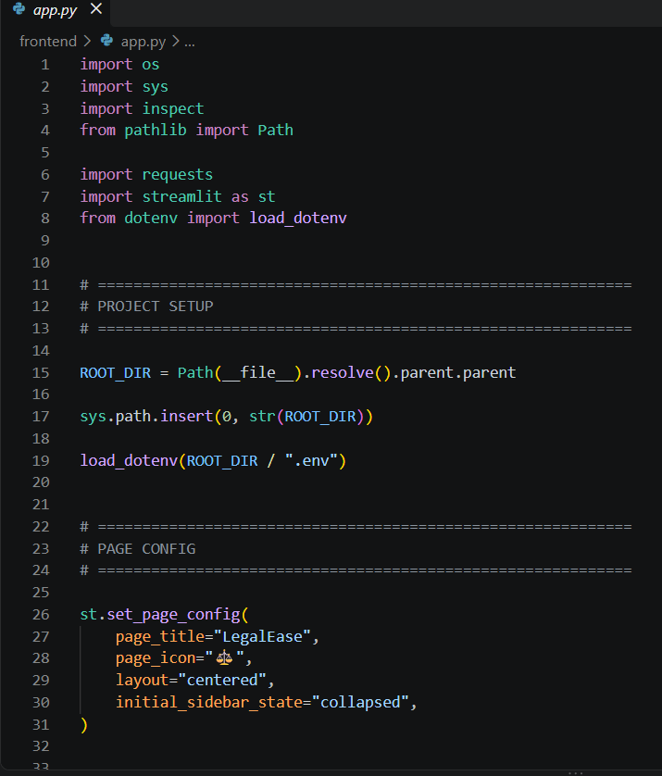
Fig. 12.6 – Streamlit frontend initialization and page configuration (frontend/app.py screenshot to be inserted)

12.7 User Interface Styling and Theme
The stylesheet defines the application's Luna Blue + Green design system. CSS variables are used for navy, blue, dark blue, teal, green, background, text, muted text, border, and success-state colors. Centralizing these values makes the visual identity easier to maintain consistently across the frontend.
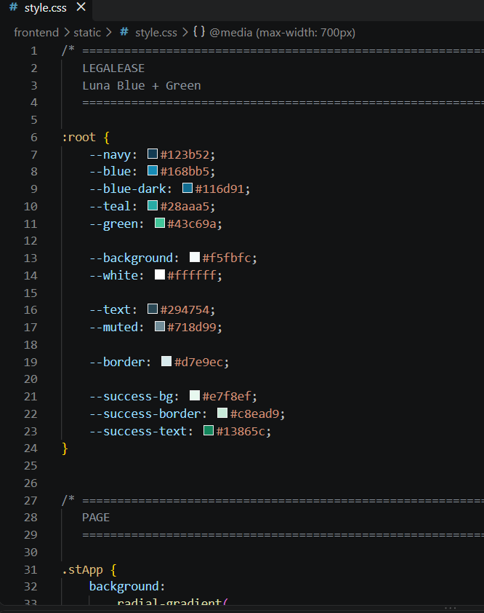
Fig. 12.7 – Luna Blue + Green frontend styling configuration (style.css screenshot to be inserted)

13. Testing Summary
Testing evidence currently available consists primarily of successful application startup and source-level configuration checks. The supplied terminal screenshot shows that python run.py was executed from the activated virtual environment and that the backend and frontend services started without a displayed startup error.
13.1 Startup Test
Expected result: the launcher should start the backend and frontend services and report their local addresses. Observed result: the terminal reports the backend at 127.0.0.1:8000, the Gemini model as loaded, application startup as complete, and the Streamlit frontend at localhost:8501.

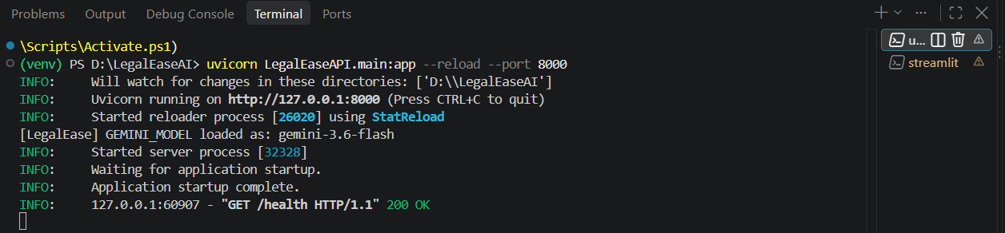
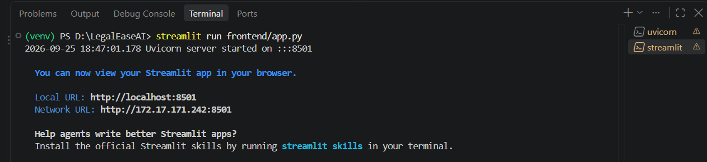
Fig. 13.1 – Successful LegalEaseAI service startup shown in the VS Code terminal

13.2 Source-Level Integration Checks
- Backend application creation is visible in main.py.
- Router registration is visible in main.py.
- CORS middleware configuration is visible in main.py.
- Gemini generator initialization and readiness/error handling are visible in routes.py.
- Pydantic request modeling and field constraints are visible in routes.py.
- Environment-based API-key loading is visible in gemini_generator.py.
- Text sanitization and formatting logic are visible in formatter.py.

13.3 Testing Evidence Still Required
For a complete Phase 7 evidence set, browser screenshots should later be added for the home screen, input form, generation action, generated result, and download/output stage. These are deliberately marked as pending rather than being invented.

14. Screenshots / Evidence
The evidence section consolidates the visual proof collected during implementation. Code screenshots demonstrate the internal structure and implementation, while runtime screenshots demonstrate execution. The following evidence is already available:
ID | Evidence | Source | Status | Purpose
E-01 | Project structure | VS Code Explorer | Available | Project organization
E-02 | Application startup | VS Code terminal | Available | Backend/frontend startup and local addresses
E-03 | run.py | Source code | Available | Service startup configuration
E-04 | main.py | Source code | Available | FastAPI initialization and router registration
E-05 | routes.py | Source code | Available | API routing, validation, Gemini initialization
E-06 | gemini_generator.py | Source code | Available | AI service configuration
E-07 | formatter.py | Source code | Available | Sanitization and formatting
E-08 | frontend/app.py | Source code | Pending screenshot | Streamlit frontend implementation
E-09 | style.css | Source code | Pending screenshot | Visual theme implementation
E-10 | Running frontend | Browser | Pending screenshot | Actual user interface
E-11 | Generated output | Browser | Pending screenshot | End-to-end result

14.1 Screenshot Formatting Standard
- Center each screenshot on the page.
- Preserve the original aspect ratio; never stretch a screenshot.
- Use a thin dark-blue border around screenshots.
- Use a centered, italic dark-green caption directly below each figure.
- Crop unnecessary desktop taskbar or unrelated panels where possible.
- Do not expose API keys, tokens, passwords, or other secrets in screenshots.

15. Installation and Execution

15.1 Project Setup
The project includes a dedicated venv directory, indicating a local Python virtual environment. The project root also contains requirements.txt for dependency declaration and .env/.env.example files for environment configuration.
- Open the LegalEaseAI project folder in Visual Studio Code.
- Create or activate the project's Python virtual environment.
- Install the dependencies listed in requirements.txt.
- Create the required environment configuration based on .env.example.
- Provide the Gemini API key through the environment variable expected by gemini_generator.py.
- Run the application launcher with python run.py.

15.2 Starting the LegalEaseAI Application
The run.py launcher starts the backend and frontend services. The supplied terminal evidence shows the command python run.py running inside the activated virtual environment. The backend is reported on port 8000 and the Streamlit frontend on port 8501.
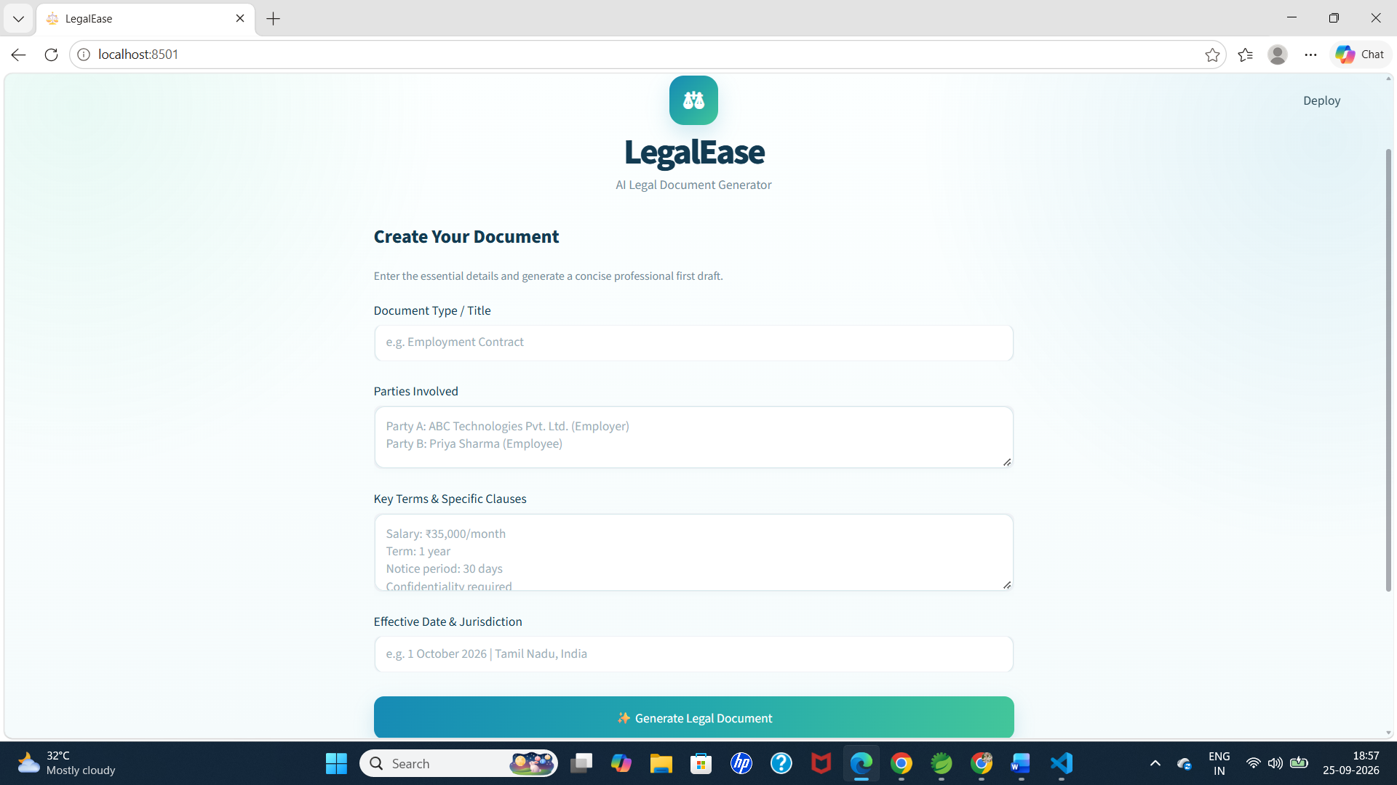
Fig. 15.1 – Successful startup of the LegalEaseAI backend and frontend services

15.3 Accessing the Local Application

Backend address shown by the startup output: http://127.0.0.1:8000
Backend health address shown by the startup output: http://localhost:8000/health
Frontend address shown by the startup output: http://localhost:8501

Security note
Keep the real .env file private. The project should use environment variables for API credentials, and screenshots/documentation should never display the secret value.
16. Project Outcomes
Based on the supplied implementation and runtime evidence, the project achieves a modular application structure with a working local startup process. The backend is configured as a FastAPI service, the frontend is configured as a Streamlit application, and a dedicated Gemini service is integrated into the API layer.
- A clear separation between frontend, backend, AI, and formatting responsibilities.
- A single startup script for launching the application services.
- Environment-based configuration for Gemini credentials.
- Structured request modeling and validation.
- Explicit AI-service readiness/error state during initialization.
- Text sanitization and document-formatting support.
A defined blue-green visual theme for the frontend.
The end-user outcome should be documented with browser screenshots once available. In particular, the generated legal-document result should be included as the strongest evidence of the complete end-to-end workflow.

17. Future Enhancements
The following enhancements are proposed as logical future work for a project of this architecture. They are presented as development opportunities rather than claims about functionality already implemented.
Add user authentication and role-based access if the application is deployed beyond local use.
Add persistent storage for document history, user requests, and generated files.
Add stronger validation for document-specific fields and domain rules.
Add automated unit and integration tests for API routes, validation, formatting, and AI-service error paths.
Add structured logging and monitoring for production deployments.
Add versioned prompt templates and configurable generation settings.
Add richer document templates and formatting controls.
Add multilingual document generation where appropriate.
Add secure file storage and controlled download permissions.
Add deployment configuration for a cloud environment.
Add browser-level test evidence for the complete user workflow.

18. Conclusion
- LegalEaseAI presents a modular approach to AI-assisted legal document generation. The supplied project evidence demonstrates a clear division between application startup, FastAPI backend initialization, API routing and validation, Gemini integration, document formatting, and Streamlit presentation.
- The implementation is supported by a structured project tree and a successful local startup sequence. The source code also shows environment-based AI configuration, request validation, error-state handling, and document-oriented formatting utilities. Together, these components provide a technical foundation for the intended application workflow.
- For the final Phase 7 submission, the remaining high-value evidence is the running frontend: the user interface, input stage, generation stage, generated document, and download/output stage. Adding those screenshots will complete the visual proof of the end-to-end system and make the documentation substantially stronger.
Final submission
Evidence sequence consistent: Project Structure → Startup → Backend → Routes → Gemini → Formatting → Frontend → User Input → Generated Output → Download/Result.

